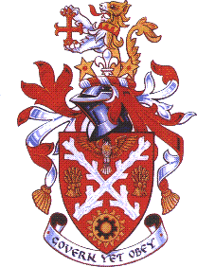
North Warwickshire
Borough Council

Rent Payments
Instruction to your
bank or building society
to pay Rent by Direct Debit
Name and full postal address of your bank or building society |  |  |  |  |  |  |  |  |  |  |  | Service user number
To: The Manager  Bank/Building Society  Bank Postal Address  Post Code |  |  |  |  |  |  |  |  |  |  |  | 9 | 4 | 0 | 7 | 6 | 2
Please fill in the whole form using a black ball point pen and send it to:

North Warwickshire Borough Council
The Council House
South Street
Atherstone
Warwickshire
CV9 1DE

Name(s) of account holder(s)
Bank/building society account number
Branch sort code |  |  |  |  |  |  |  |  |  |  |  | Rent Reference
Instruction to your bank or building society

Please pay North Warwickshire Borough Council Direct Debits from the account detailed in this Instruction subject to the safeguards assured by the Direct Debit Guarantee.
 |  |  |  |  |  |  |  |  |  |  |  | Signature(s)
 |  |  |  |  |  |  |  |  |  |  |  | Date
 |  |  |  |  |  |  |  |  |  |  |  | Your address
 |  |  |  |  |  |  |  |  |  |  |  | ____________________________________
 |  |  |  |  |  |  |  |  |  |  | 5th | Tick the box for your preferred payment date:  25th  15th
Every Monday | OR Monthly on
Banks and building societies may not accept Direct Debit Instructions for some types of account
DDI1

This guarantee should be detached and retained by the payer.

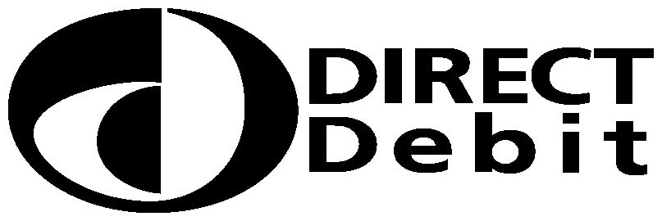
The
Direct Debit
Guarantee
- This Guarantee is offered by all banks and building societies that accept instructions to pay Direct Debits
- If there are any changes to the amount, date or frequency of your Direct Debit North Warwickshire Borough Council will notify you at least 10 working days in advance of your account being debited or as otherwise agreed. If you request North Warwickshire Borough Council to collect a payment, confirmation of the amount and date will be given to you within 10 working days.
- If an error is made in the payment of your Direct Debit, by North Warwickshire Borough Council or your bank or building society, you are entitled to a full and immediate refund of the amount paid from your bank or building society
– If you receive a refund you are not entitled to, you must pay it back when North Warwickshire Borough Council asks you to
- You can cancel a Direct Debit at any time by simply contacting your bank or building society. Written confirmation may be required. Please also notify us.

